Using Your IPAD to join a St. John’s Sunday Service or other virtual events

If you will be using your IPAD follow these instructions. You will only have to do this one time.
You will be downloading ZOOM but you do not need an account or logon or password.
If you have any trouble with this, we can help you.

1) On your IPAD, double click (open) the App Store 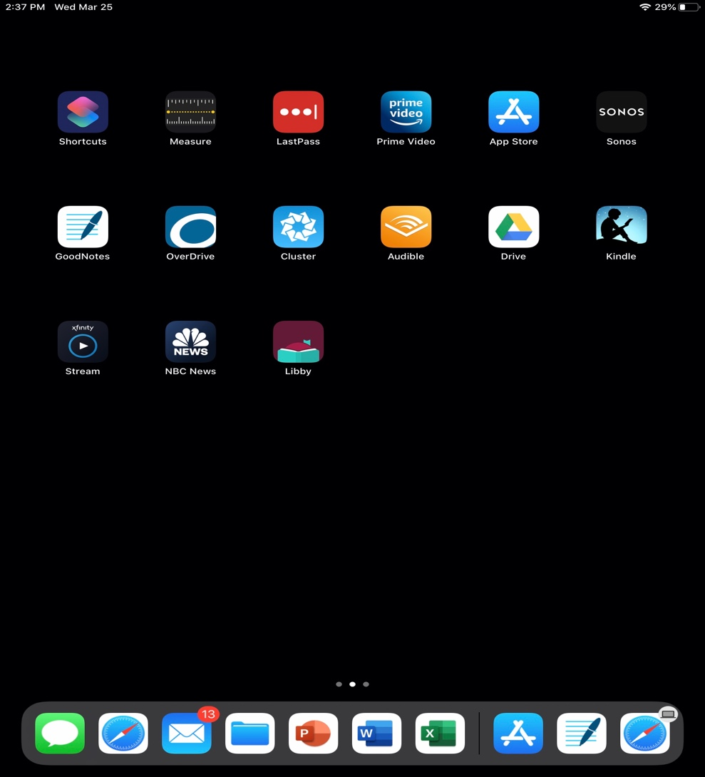

2) In the Search bar, type Zoom and then press Search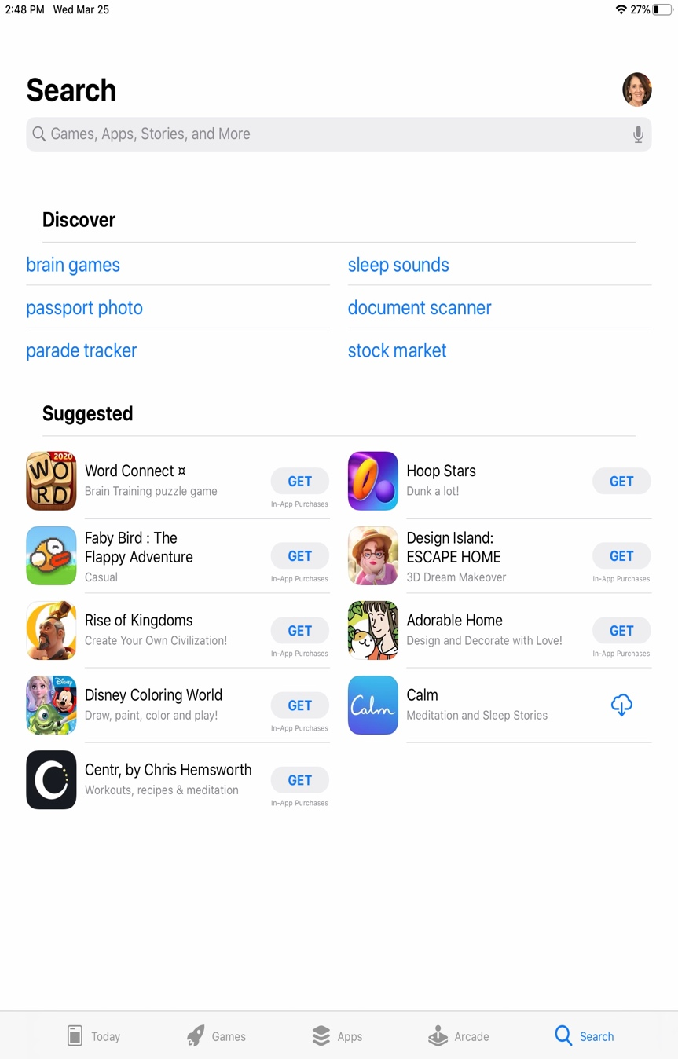

3. Find the ZOOM CLOUD MEETINGS and click on the Cloud download symbol.
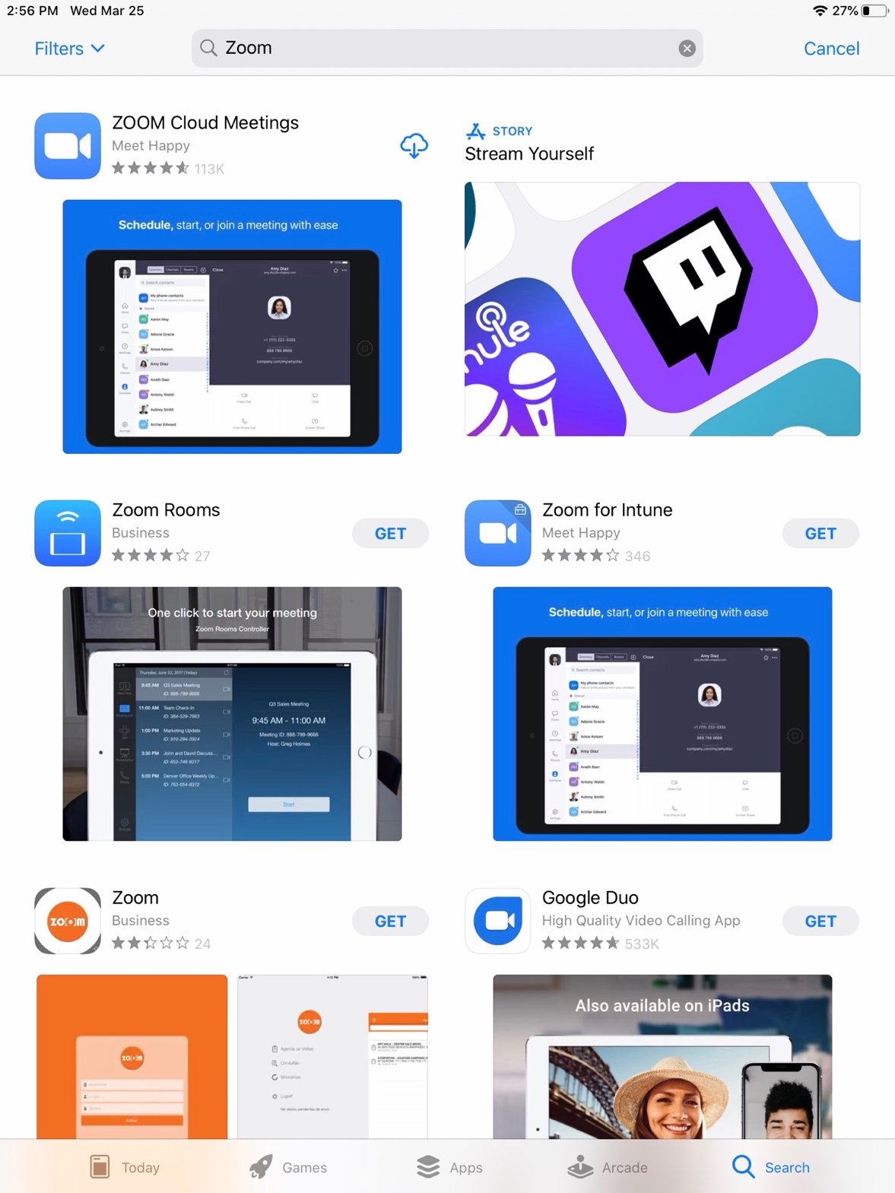

4. When the download is complete it will look like this. Click OPEN.

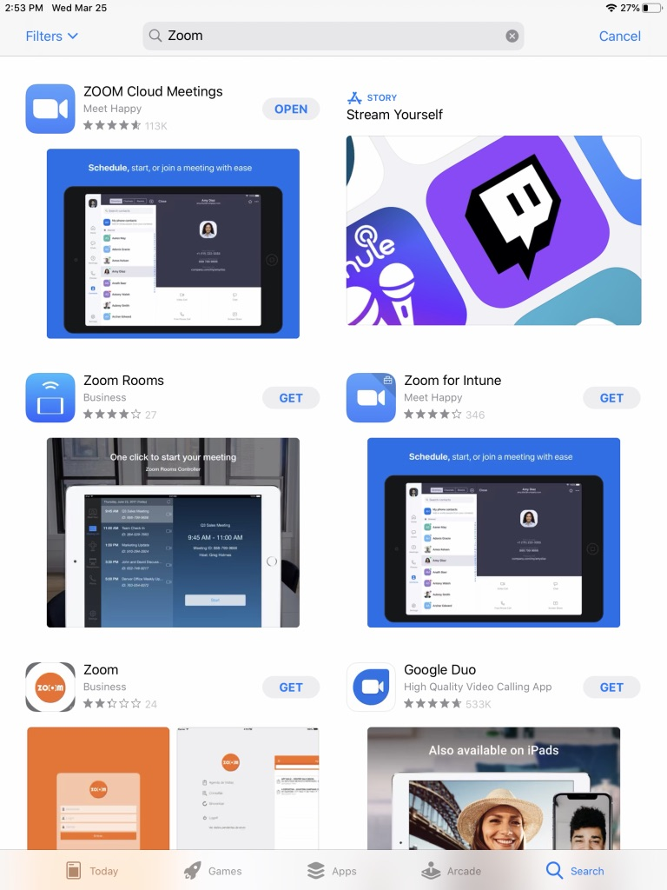

5. Then you will see this screen. You have successfully downloaded ZOOM.
You can get out of this screen by pressing your HOME button.

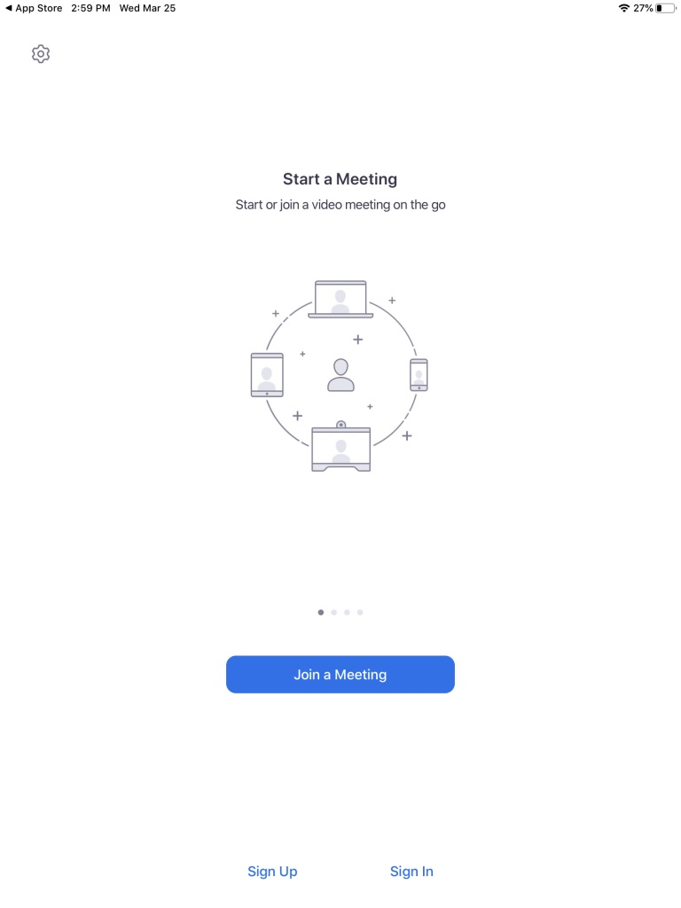

6. You will now see Zoom on your IPAD screen but you do not have to open Zoom to participate in the Sunday services.

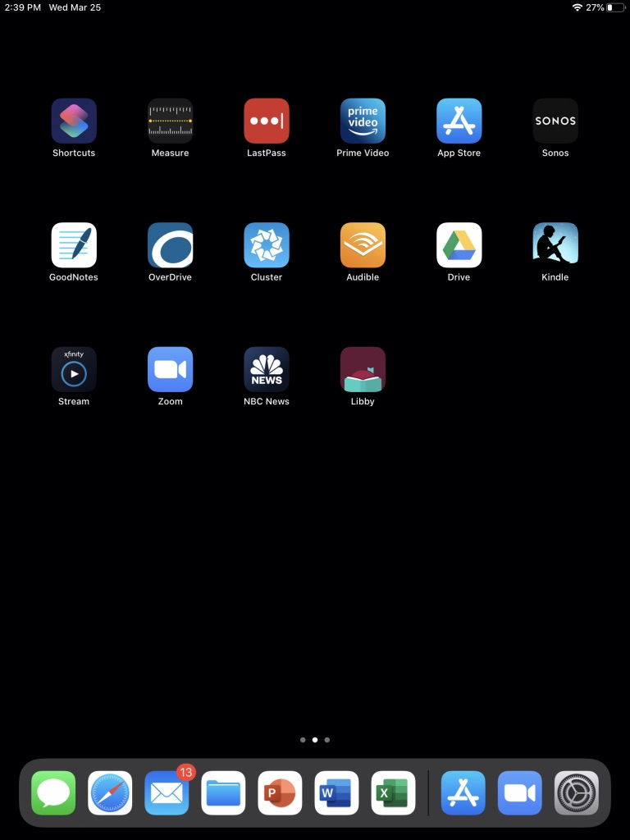

7. To access the Sunday Service at 10:00, you will simply click the zoom invitation that Beth Taylor posts on Facebook, from the Enews email or from the St. John’s webpage.
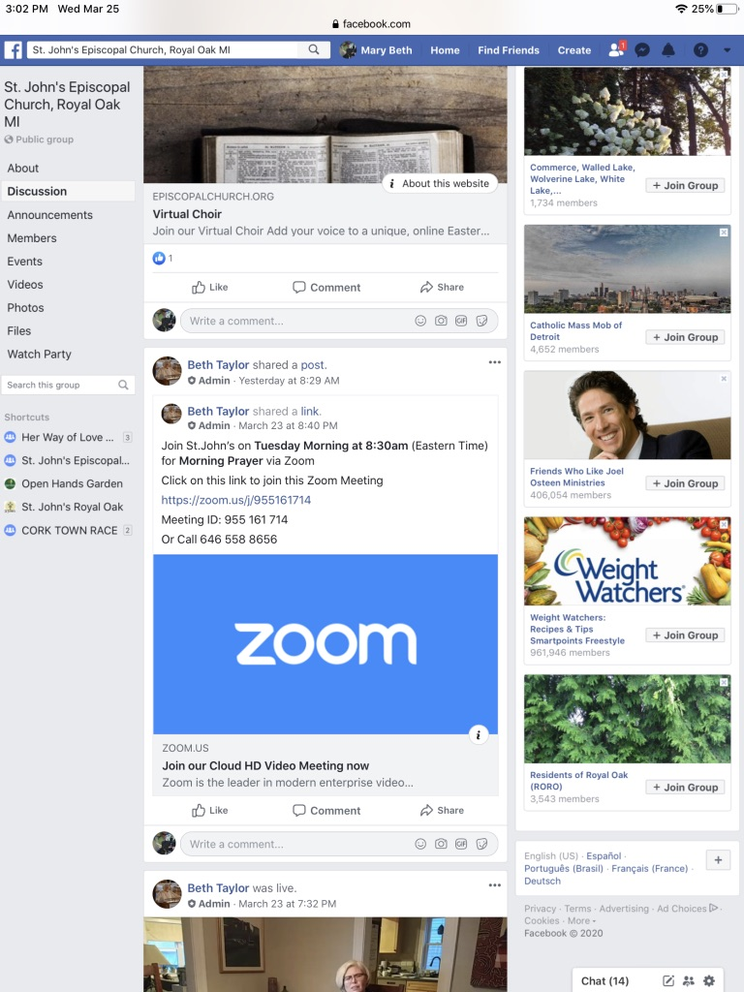
8. You will be asked to connect with video. If you are ok being seen yourself say YES.
You will be asked to connect with your IPAD’s audio, say YES.

Please contact us if we can help you. https://www.stjohnsroyaloak.org/contact-us

